NVE Field Audit (FA) WorkFlow

This document intends to cover major details, with UI workflow, APIs, states & database changes for NVE Field Audit Tool.

Design Doc: <https://docs.google.com/document/d/1iVF_sZBuroItczW2-OK87-Q-jHkfd8RC5_wiUWUqw3U/edit?usp=sharing>

# NVE FA Credentials for UAT

URL: <https://nve-adminuat.bidgely.com>

Username: mohammed+fa@bidgely.com

Password:

# DRMS file: FieldAuditTask Format

We receive file **FieldAuditTasks_YYYYMMDDhhmm.gpg** at around <add_here> PM in SFTP folder: /workdir/prod and cron copies to /workdir/prod_delayed to be picked by IngesterClient. Archives are added in /workdir/archive/prod.

**Sample decrypted File: FieldAuditTasks_201901012200_01-0.txt**

Sample File:

11,1000020548301599091,929918,2019-01-02,16:00:00

19,1000026470202080523,931192,2019-01-02,13:00:00

8,1000069979201665942,930388,2019-01-02,08:00:00

20,1000092572201326218,931332,2019-01-02,16:00:00

5,1000094016002327908,929872,2019-01-02,08:00:00

17,1000195753001837150,930258,2019-01-02,08:00:00

14,1000245906801571714,929796,2019-01-02,08:00:00

2,3000101787522938296,927622,2019-01-02,08:00:00

18,3000110744410800798,926952,2019-01-02,08:00:00

12,3000122709619770494,928534,2019-01-02,08:00:00

22,3000124222615130687,923383,2019-01-02,13:00:00

6,3000135104410047331,929304,2019-01-02,16:00:00

3,3000139637814384749,929697,2019-01-02,08:00:00

16,3000155534623081351,928755,2019-01-02,13:00:00

4,3000182669521362854,929292,2019-01-02,08:00:00

15,3000186614918796773,926261,2019-01-02,08:00:00

13,3000223728911315442,925676,2019-01-02,13:00:00

9,3000239833310445378,929337,2019-01-02,16:00:00

23,3000321146512058793,932072,2019-01-02,08:00:00

1,3000327719915766842,929520,2019-01-02,13:00:00

7,3000339846717930593,926401,2019-01-02,13:00:00

21,3000350798611855620,929442,2019-01-02,13:00:00

10,3000351293619284758,929709,2019-01-02,08:00:00

LINE NUMBER,ACCOUNT NUMBER,TASK ID,FIELD AUDIT DATE,FIELD AUDIT TIME

Recent Code changes Made:

The parser will ignore header information in the file, which used to throw errors in the log.

# Databases

We maintain 4 tables in MySQL database for Field Audit

## audit_schedules

This table stores all audit schedules for a pilot.

Schema

pilot_id - 10009 for NVE

user_id - UUID for the user (converted from Account Number field sent in the DRMS file)

work_order_id - Task ID sent in the file

audit_timestamp - Epoch time (converted from FIELD AUDIT TIME sent in the file)

schedule_file_name - Name of the file ingested

schedule_status - Two States: CANCELLED & SCHEDULED

last_modified_timestamp - Table Entry lastModifiedTime

IMPORTANT: When NVE sends us a new DRMS file, it sends us a list of customers for which Field Audit needs to happen that day. And when this file comes, we update all previous schedule_status as CANCELLED and new ones as SCHEDULED.

And schedule_status as CANCELLED doesn’t tell whether Field Audit was not completed or it got cancelled. It just tells whether Field Audit is to happen for that work_order_id until the new file comes.

A CANCELLED state may mean that Field Audit was completed a day before.

Also, the tasks that NVE give doesn’t map it to any particular auditor. Auditor needs to go to the tool and search for a particular work order id and schedule it.

## auditors_worklist

This table stores most of the audit details including its state.

Schema

auditor_id - UUID for auditor (who has scheduled the task by searching in the tool)

work_order_id - Task ID

user_id - UUID for the user

meter_id - meter id for Field Audit

audit_timestamp - Epoch time for audit (sent in the DRMS file)

status - status for FA (see below for possible values)

reason - the reason for FA (see below for possible values)

additional_info - String (some metadata)

audit_completion_status - epoch timestamp when FA is completed (NULL if FA is not completed yet)

last_modified_timestamp - Table Entry lastModifiedTime

audit_type - field_audit as default

locale

status can take following 5 values

PENDING - when field audit is not started but scheduled by auditor

STARTED - when field audit is started by the auditor

COMPLETED - when field auditor completes FA after signing

FA_REPORT_SENT - when report PDF is generated and saved in S3

DELETED - when FA is deleted by the auditor.

Things to Note for Status

User always passes through COMPLETED status before moving to FA_REPORT_SENT/DELETED. COMPLETED can be marked when users signature is entered or explicitly via updating status. When the users' status is marked completed for the first time (not toggling from FA_REPORT_SENT) then the event is to marked in redshift as well.

Although there's a strict hierarchy between the status, users' status can be toggled between COMPLETE ⇔ FA_REPORT_SENT.

The status does not transition to the DELETED state without going through the completed state. This behavior should be adhered to, as this premise is used in the HybridModel code, to filter out FA recommendations, if the field audit has already been done for a user in the past N days, where N is pilot configurable.

reason can take following 4 values

HIGH_BILL_CALL,

GENERAL_HOME_INSPECTION,

HOUSEHOLD_RELATED_ENERGY_QUESTIONS,

OTHER,

NULL (if it is not yet “added to worklist” or scheduled by the FA auditor)

Important thing to note for auditors_worklist

1. This table doesn’t get any entry when DRMS file is ingested.
2. It only gets an entry once an auditor uses FA tool to search for the task and schedule it with a reason.

## audit_report

This table stores details about the Field Audit report PDF.

Schema

auditor_id - UUID for auditor

user_id - UUID for the user

work_order_id - task ID

fa_report_s3_path - full s3 path where PDF was saved (NULL initially)

locale

copy_provided - 0 (default) or 1 (whether a copy is provided) [NVE doesn’t use this]

need_email - 0 (default) or 1 (whether the customer wants the report via email from utility)

need_us_mail - 0 (default) or 1 (whether the customer wants the report to be sent via postal mail from utility) [NVE doesn’t use this]

last_modified_timestamp - table entry lastModifiedTime

audit_type - string, field_audit as default

Similar to auditors_worklist, an entry is created in this table only when an auditor schedules the FA. And, until the FA is completed & report is successfully saved to S3, fa_report_s3_path will be NULL. After PDF is saved in s3, status in the auditors_worklist table will be FA_REPORT_SENT

## audit_signatures

This table stores PII information like auditor signature (as abse64 encoded string), contact name, etc

Schema

auditor_id - UUID for auditor

work_order_id - task ID

signature - base64 encoded String

audit_start_timestamp

signature_timestamp - epoch timestamp

contact_firstname

contact_lastname

# Pilot Configurations

Config Type: field_audit_preferences

Config Keys:

1. worklist_limit_in_days - Denotes the max size of past audits (scheduled by auditor) to be returned by the API (30 for NVE)
2. signature_required - boolean, whether signature is a requirement for the utility or not. True for NVE
3. s3_url_timeout_in_sec - 864000 for NVE
4. fa_pdf_base_url - http://nve.bidgely.com for NVE

# Flow Chart

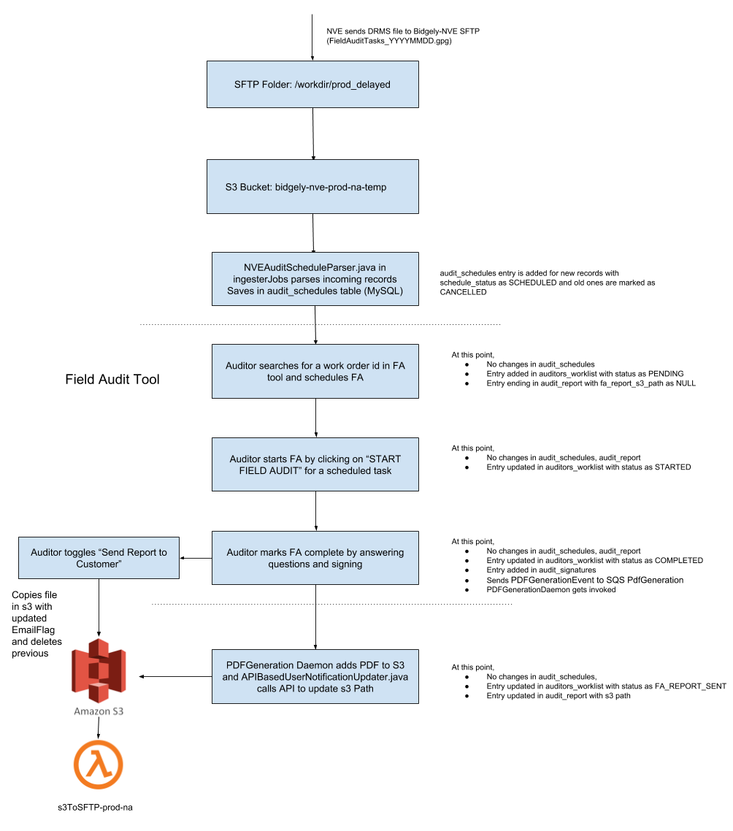

# FA PDF File Location and Format

For NVE, it is saved in s3://bidgely-pdf-reports-prod-na/10009/FA/default and has format: FA_{{AccountID}}_{{WorkOrderID}}_{{YYYYMMDDHHmmss}}_{{EmailFlag}}_{{Iteration}}.pdf

Ex., FA_1000010225201015427_889879_20181030184700_1_1.pdf

EmailFlag tells NVE whether report needs to be emailed to the customer from utility.

IMPORTANT: We may add another flag {{DirectInstallFlag}}. Updated FA file format would be- FA_{{AccountID}}_{{WorkOrderID}}_{{YYYYMMDDHHmmss}}_{{EmailFlag}}_{{DirectInstallFlag}}_{{Iteration}}.pdf

DirectInstallFlag = 1 means any one of the 31 questions in the Direct install tab is answered.

[JIRA#ENGNVE-302](https://bidgely.atlassian.net/browse/ENGNVE-302)

# s3ToSFTP Lambda and its quirks

The lambda function gets triggered when s3 file is generated and transfers file from S3 to Utility SFTP (/workdir/bidgely-output/prod/PDF_tmp) for NVE. Check “sftp_pull” - “sftpServerPdfReportDirectory” and “pdfReportDelayedTransfer” configs for these fields.

Git Code: <https://github.com/bidgely/Utils/tree/master/lambda/s3ToSFTP>

This lambda works async to PDFGeneration module which has caused one issue.

There is a option where the auditor can mark “Send Report to Customers” toggle button to denote whether report needs to be sent to the customer or not. It is checked by default and on unchecking it, an API is called which copies S3 file with the same content but changed filename - as toggled EmailFlag. The previous file is deleted from the bucket, but lambda was triggered trying to copy it to SFTP and may find source deleted during operation and leave empty files in SFTP.

Working on this fix from the design perspective.

# FA Tool Screenshots

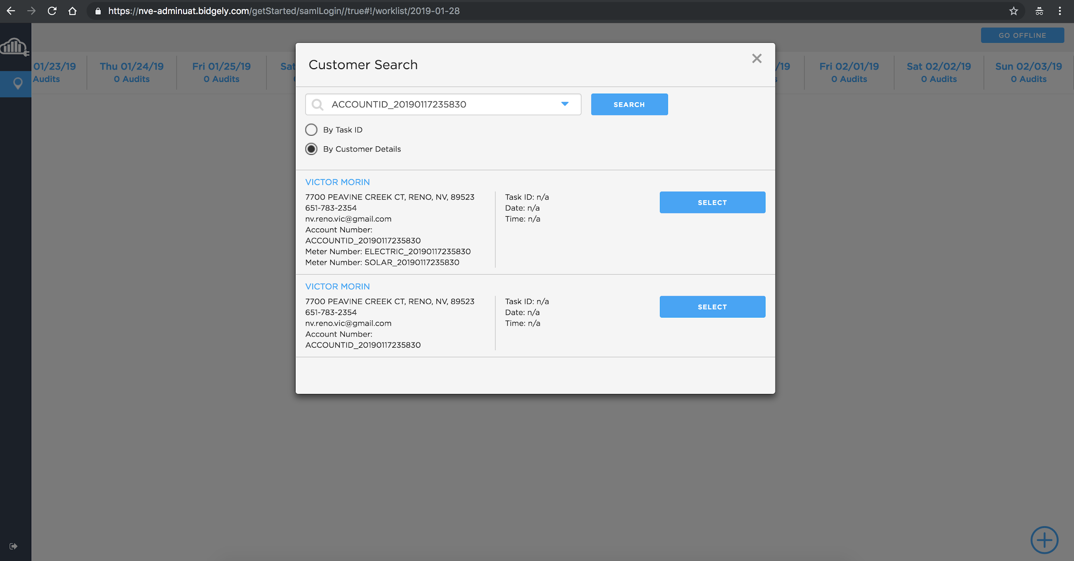

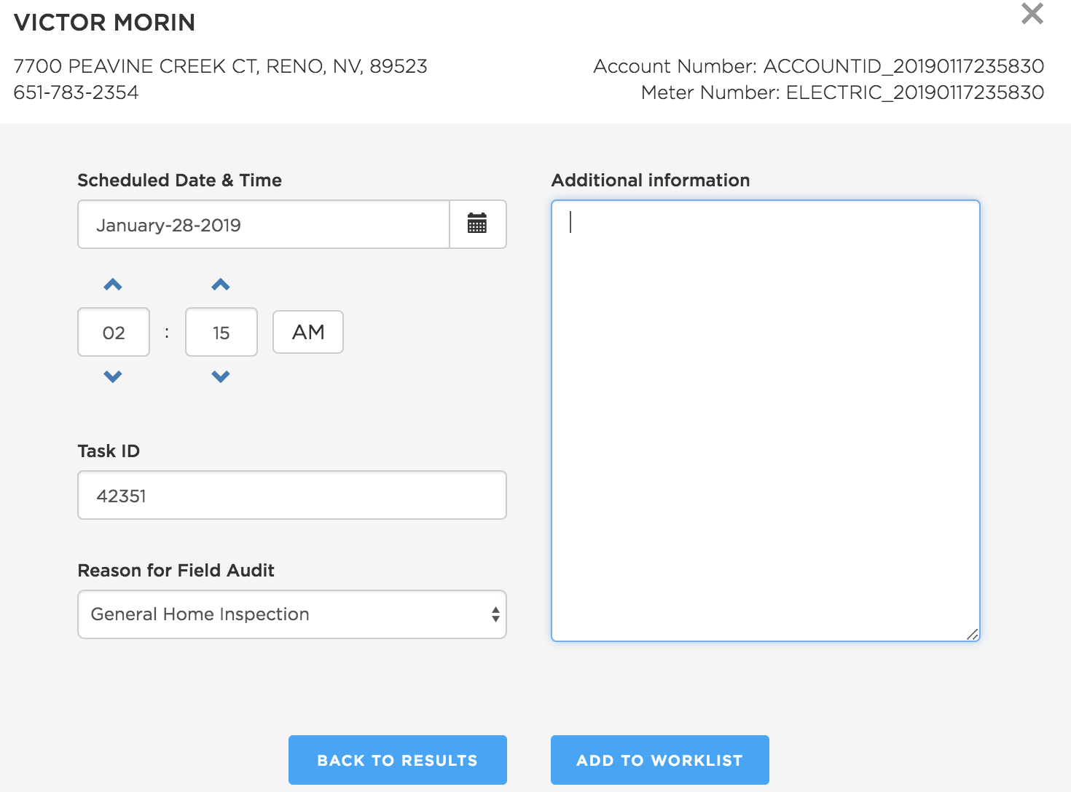

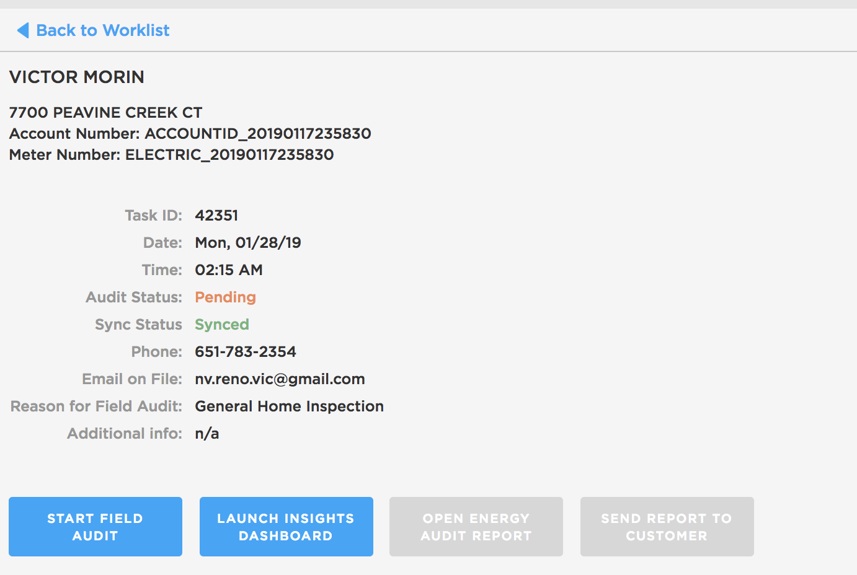

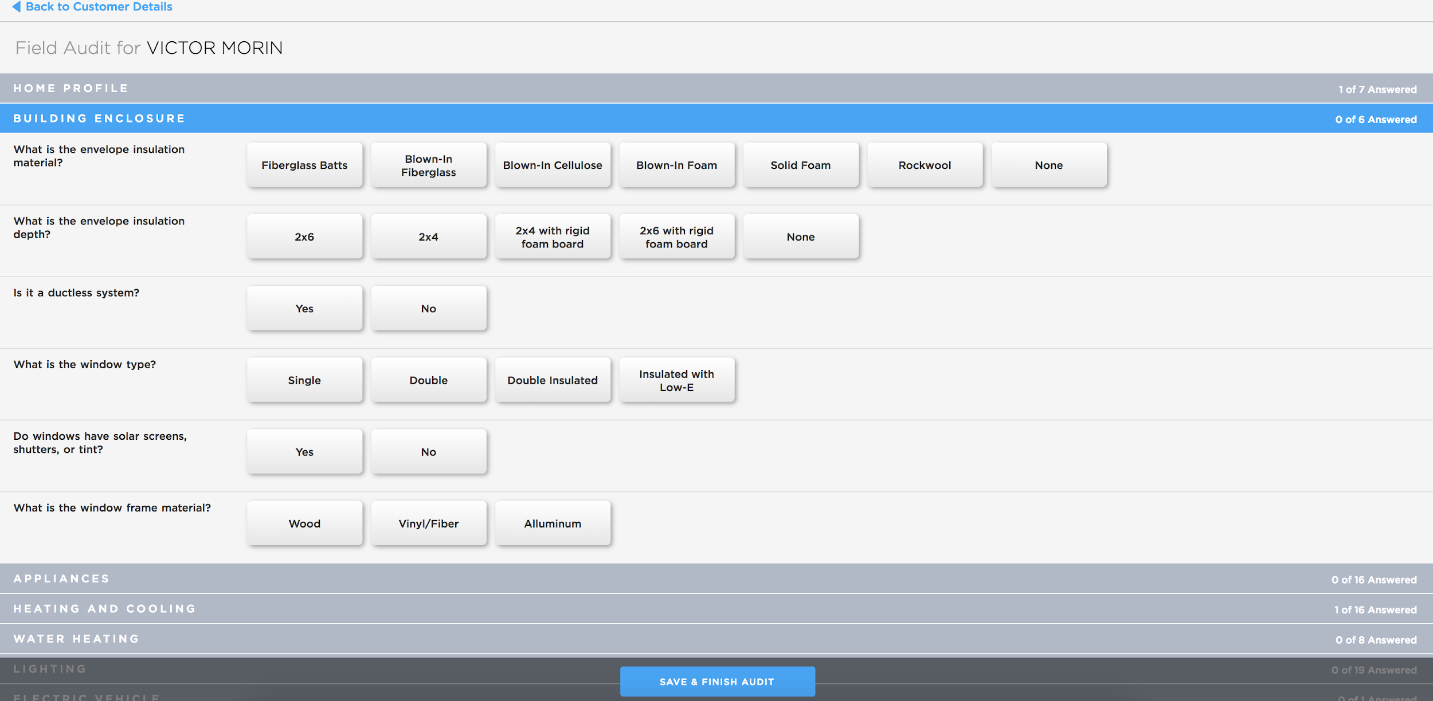

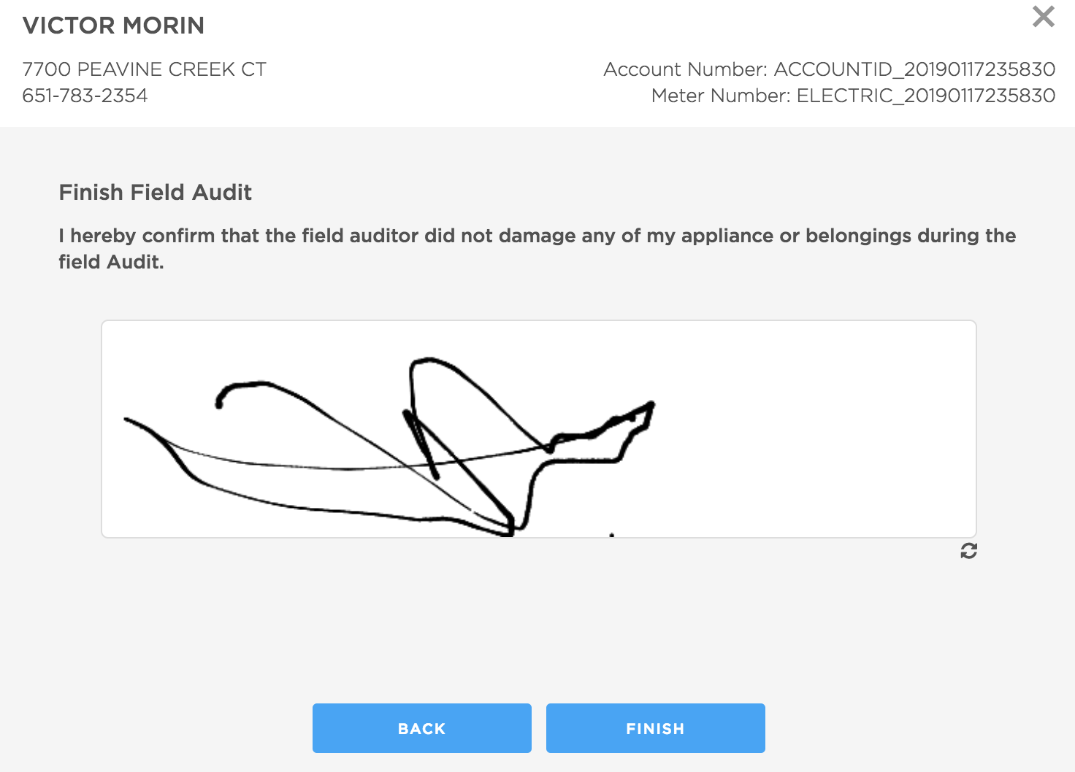

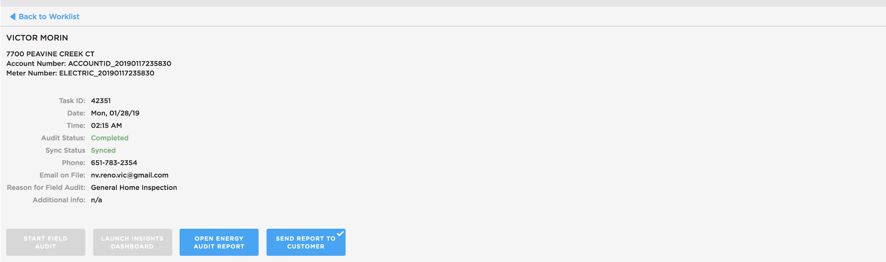

# Imp APIs

**GET** v2.0/field-audit/{auditorId}/worklist

Gets the worklist details of an auditor. If the limit is specified then it's used to fetch those number of days' data else limit from field_audit_preferences is used. If workOrderId is specified then only that result is audit pertaining to that workOrderId is fetched.

**GET** v2.0/field-audit/user/{userId}/previous-audits

Gets the latest completed audits for a particular userId

**GET** v2.0/field-audit/user/{userId}/worklist/{workOrderId}

Returns AuditReportDetails record from audit_report table for specified userId and workOrderId.

**PUT** v2.0/field-audit/user/{userId}/worklist/{workOrderId}/audit-report

Update audit_report table, with the AuditReportDetails object in request for specified userId and workOrderId. Only those fields which are specified in request are updated, other fields retain their old values.

Any changes to the payload(AuditReportPayload) in this api, the same should be made in

com.bidgely.cloud.pdf.generation.daemon.APIBasedUserNotificationUpdater.updateS3Path(PDFGenerationEvent, String)

**PUT** v2.0/field-audit/{auditorId}/worklist/{workOrderId}

Insert/schedules the audit for auditorId and workOrderId. The same can be updated using this API. Only given fields are updated.

**PUT** v2.0/field-audit/{auditorId}/worklist/{workOrderId}/locale/{locale}

**PUT** v2.0/field-audit/{auditorId}/worklist/{workOrderId}/{status}

Updates the status for FA

**DELETE** v2.0/field-audit/{auditorId}/worklist/{workOrderId}

Deletes the scheduled audit, if signature is not present for it. This also updates status in auditors_worklist to DELETED.

**GET** v2.0/field-audit/user/{userId}/latest-audit

This api returns audit details of the last completed audit for this user. Work order id returned by this api is used to display FA custom recommendations on the dashboard.

**GET** v2.0/field-audit/{auditorId}/worklist/{workOrderId}/signature

Get the user signature & date pertaining to an audit.

**POST** v2.0/field-audit/{auditorId}/worklist/{workOrderId}/signature

Upserts a given signature in audit_signatures with date.

**GET** v2.0/field-audit/schedules/{workOrderId}

Get pre-scheduled audit for the given pilot and workOrderId (taskId).

**GET** v2.0/field-audit/schedules

Get all pre-scheduled audits for an utility. Query param: schedule_status should be sent as SCHEDULED or CANCELLED.

**GET** v2.0/field-audit/pending-schedules

Get all pre-scheduled audits for a list of users sent in query param. Query param: schedule_status should be sent as SCHEDULED or CANCELLED.

## PDF Generation APIs

**POST** {analytics-server-base-url}/v2.0/generate-pdf/field-audit-report

API to generate and save Field audit PDF report.

**PUT** {analytics-server-base-url}/v2.0/generate-pdf/field-audit-report

API to rename field audit PDF reports.

**POST** {analytics-server-base-url}/v2.0/generate-pdf/get-pdf

Search API to search for a user based on account number to schedule audit.

# Offline FA

The auditor can conduct FA while being offline. Front end uses Service Workers to store FAs in the device itself when the auditor is offline. Once, auditor manually syncs the FA, FA is saved to DB.

Max limit for offline FA stored in the device is 30 and auditor need to manually delete old FA if he is trying to add 31st field audit while being offline.